Recordkeeping for  Good Governance Toolkit | 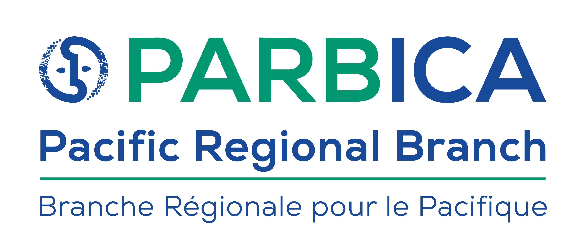
GUIDELINE 20:
Developing a Disaster Preparedness Plan

Acknowledgements
The disaster management guidelines of the PARBICA Recordkeeping for Good Governance Toolkit were kindly supported by the Programme Commission of the International Council on Archives.
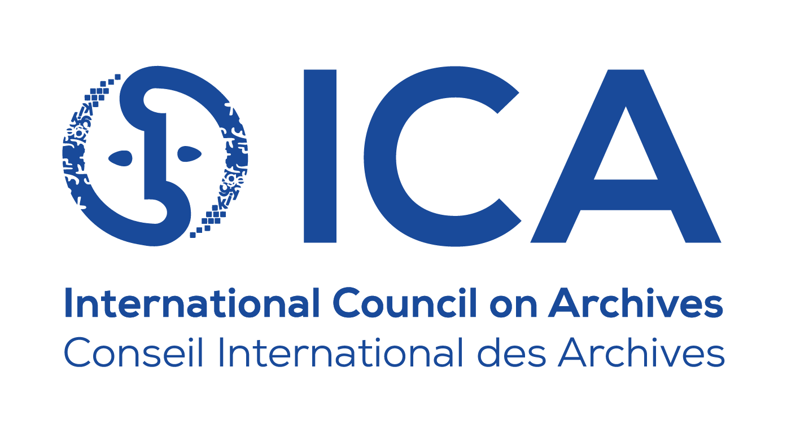
Project Managers: Fiona Gunn and Helen Walker, National Archives of Australia
Authors: Brandon Oswald, Island Culture Archival Support
Lillie Le Dorré / Talei Masters, Archives New Zealand
Fiona Gunn, National Archives of Australia
Thanks to the following people who provided advice on the guidelines,
peer-reviewed the guidelines and provided editing support:
- Opeta Alefaio, National Archives of Fiji
- Eric Boamah
- Greg Doolan
- Margaret Inifiri, National Archives Solomon Islands
- Tukul Kaiku
- Emilie Leumas and Gregor Trinkaus-Randall, ICA Expert Group on Emergency Management and Disaster Preparedness
- Linda Macfarlane and Monique Nielsen, National Archives of Australia
- Tess Perez, Yap State Archives
- Noa Petueli Tapumanaia, Tuvalu National Library and Archives
- Ros Russell
- Amela Silipa, National Archives and Records Authority Samoa
- Margaret Terry and Augustine Tevimule, Vanuatu National Library and Archives.
Special thanks to the PARBICA Bureau.
The original version of this guideline was prepared by the Pacific Regional Branch of the International Council on Archives (PARBICA) for use by countries around the Pacific.

We hope that you will use and adapt this guideline to suit your own organisation’s needs and arrangements. In your use of this guideline, PARBICA only asks for attribution and for you to please let us know how you have used it – this helps us to measure the impact of the Toolkit.

If you have any questions about, or feedback on, these guidelines, please contact PARBICA at parbica.treasurer@naa.gov.au or via any of the contacts on the website: http://www.parbica.org.

The original version of this guideline was prepared by the Pacific Regional Branch of the International Council on Archives (PARBICA) for use by countries around the Pacific.
We hope that you will use and adapt this guideline to suit your own organisation’s needs and arrangements. In your use of this guideline, PARBICA only asks for attribution and for you to please let us know how you have used it – this helps us to measure the impact of the Toolkit.
If you have any questions about, or feedback on, these guidelines, please contact PARBICA at parbica.treasurer@naa.gov.au or via any of the contacts on the website: http://www.parbica.org.

Contents

Acknowledgements 2
Introduction 4
Who is this guideline for? 4
What is a disaster? 4
Why have a Disaster Preparedness Plan? 5
What is disaster preparedness? 6
The elements of a Disaster Preparedness Plan 6
How to develop a Disaster Preparedness Plan 8
Step 1: Write your introduction 9
Step 2: Assess your risks 10
Step 3: Reduce your risks 12
Step 4: Establish a support network 13
Step 5: Set up a disaster response team 15
Step 6: Identify your vital and significant records 16
Step 7: Write your Disaster Response Plan 17
Step 8: Write your Disaster Recovery Plan 17
Step 9: Train your staff 17
Step 10: Review your disaster plans 18
Additional resources 20

Introduction
The Pacific Regional Branch of the International Council on Archives (PARBICA) has developed this guideline on Developing a Disaster Preparedness Plan as part of the Recordkeeping for Good Governance Toolkit. It was drafted in consultation with the Pacific Island Reference Group made up of representatives from the following countries:
- Australia
- Federated States of Micronesia
- Fiji
- New Zealand
- Papua New Guinea
- Samoa
- Solomon Islands
- Tuvalu
- Vanuatu.

Who is this guideline for?
This guideline is for staff and volunteers at archives or in records management to equip them to prepare for a disaster of any size and complexity by developing a Disaster Preparedness Plan (DPP). The process of developing a DPP will inform staff and volunteers about disasters and their consequences, and how best to prepare for and respond to these significant events. Disaster plans may also be adapted for a specific context or environment through further reading and research.
This guideline should be read alongside Guideline 21: Developing a Disaster Response Plan and Guideline 22: Developing a Disaster Recovery Plan. Preparation and planning are the best means of mitigating damage from natural disasters or other forms of destruction. These guidelines take a proactive (instead of reactive) approach to disaster preparedness.

What is a disaster?
Disasters can happen anywhere and at any time. Earthquakes, cyclones, tsunamis and civil strife can occur with little warning. Power failures, electrical faults, water leaks or human error can lead to an organisation’s assets being endangered.
We typically think of a major event when we hear the word ‘disaster’. In the context of archival management, a disaster is not always large and may not be obvious. While a disaster may be something catastrophic like a cyclone, it can also be relatively small, such as a burst pipe. In this guideline, we will consider all situations and levels of impact, particularly events that cause damage to records and collections and disrupt the flow of business and services.
There are two types of disasters - natural and man-made:
- Natural disasters include: rain and wind-storms, floods, earthquakes and volcanic eruptions. Although natural disasters cannot be prevented, they may allow time to act and measures can be taken to reduce the possibility of damage.
- Man-made disasters include fires, acts of war or violence, water damage (broken pipes and leaks), power failures and building deficiencies.

Why have a Disaster Preparedness Plan?
Cultural heritage organisations, such as archives, protect the resources and artefacts which form the cultural identity of an organisation, country, state or territory.
Culture is a bond that ties together people who belong to a particular region or community. When we define culture in its simplest form, it is as “a way of life of a group people”.
Cultural heritage resources are important for:
- Rights and entitlements:
  - Archives, especially government archives, contain the records of citizens’ rights and entitlements.
- Historical significance:
  - Cultural resources are the physical record of the events of our community and our shared experiences.
- Economic relevance
  - The loss of cultural resources can have a profound effect on economic livelihoods. Museums, libraries, archives and cultural centres across the region attract a high volume of visitors.
- Continuity of community
  - When the cultural community recovers and cultural heritage resources are restored, the community as a whole recovers more quickly and completely. This recovery seems to inspire hope and positive reactions from the community.
Cultural heritage organisations that close because of a disaster may never reopen. Those that survive have planned their response to a disaster before it strikes.
A DPP is a significant part of good archival management. In a disaster, a well prepared and practised DPP will help an organisation to resume operations as quickly as possible.
There are two priorities in disaster preparedness planning:
- to ensure human life and safety
- to protect the organisation’s assets such as its collections, resources, equipment, supplies and information.
A backup copy of the DPP should be kept offsite from the organisation. For example, the Chief Archivist and Disaster Response Coordinator should keep a copy of the plan at their homes, including encrypted USBs with emergency procedures, floor plans and business continuity plans.

What is disaster preparedness?
Disaster preparedness consists of four basic stages: mitigation, preparedness, response and recovery.

Fig 2 The four basic stages of disaster preparedness
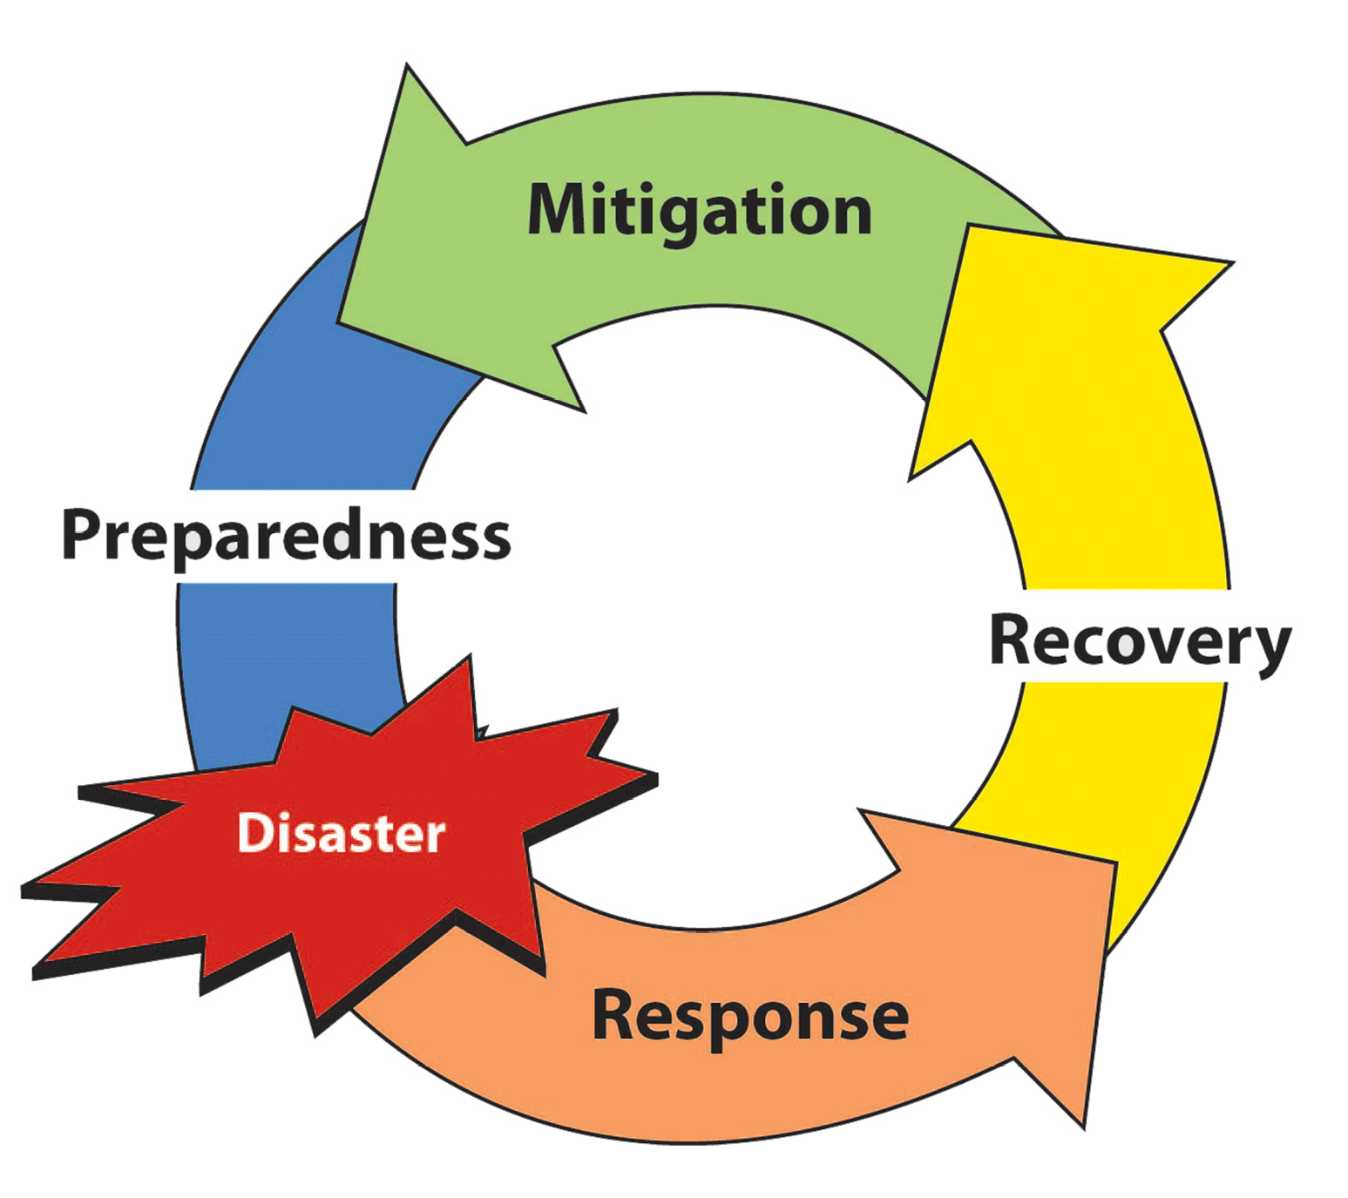

Responding to these stages involves:
  - developing an understanding of risks that your organisation is exposed to
  - alleviating those risks
  - being prepared for potential disasters.
One of the best ways to be prepared before, during and after a disaster is by writing a plan. Having a DPP allows an organisation to take action to prevent disasters from occurring and also contains the necessary procedures to mitigate damage and recover from a disaster. The impact on the staff, records, collections and building will be significantly reduced.

The elements of a Disaster Preparedness Plan
The best way to describe the basic elements of disaster management is to separate it into three stages: before, during, and after. Each stage must be considered when writing your organisation’s DPP.
Before is also referred to as Prevention and Preparation. This is the stage when risks are assessed and you take a close look at your organisation and its current situation – both the collection and the building. It is also the time to recognise the threats to your archive that you cannot control such as natural disasters, bomb threats and vandalism.
During is also referred to as Response. At this stage the disaster is occurring. The material developed during your planning and preparation will have identified the steps to be taken during a disaster - for example, when staff use emergency procedures to protect themselves or when a staff member shuts off the main water valve. Your response is crucial as it could prevent a minor disaster becoming a major one.
After is also referred to as Recovery. At this stage the disaster has occurred and your organisation’s staff has responded. Effective and fast action after a disaster will limit damage and save more of the collection, especially where water damage is involved. The first 48 hours after a disaster is crucial for the collection as mould can easily set in.
Fig 2 The elements of a disaster preparedness plan
BEFORE | DURING | AFTER
Prevention | Response | Recovery
- Assess risk  - Reduce risk | - Disaster Response Plan | - Disaster Recovery Plan  - Review and update Plan
Preparation
- Prioritise your collection
- Set up a disaster response team
- Establish support networks
- Training
Disaster Preparedness Plan
Disaster Response Plan
Disaster Recovery Plan

Knowing what to do in response to disasters is important. The organisation’s building must be declared safe to work in and the area must be stabilised to prevent further damage. Your DPP will guide you through the most critical and difficult days.

How to develop a Disaster Preparedness Plan
Your DPP may be developed in phases. An organisation may begin with a few sections of the plan focusing on issues that are of greatest concern. More detail can be added as staff gain knowledge, have time to work on the plan and are able to agree on how the organisation’s preparedness activities should be carried out.
It is not uncommon for two or more organisations to share the same building. For example, a national archives may be in the same building as the national library. Every organisation within the same building should be included in the DPP, be involved in developing the guidelines and help with disaster response and recovery stages.
There are ten steps that should be considered when preparing for a disaster. These steps may differ from organisation to organisation but once you have worked through these guiding steps you will be able to prepare a DPP to best suit your organisation.
Fig 3 The ten steps in developing a Disaster Preparedness Plan
Step 1: Write your introduction
Step 2: Assess your risks
Step 3: Reduce your risks
Step 4: Establish a support network
Step 5: Set up a disaster response team
Step 6: Identify your vital and significant records
Step 7: Write your Disaster Response Plan
Step 8: Write your Disaster Recovery Plan
Step 9: Train your staff
Step 10: Review your disaster plans

Step 1: Write your introduction
The introduction should clearly and briefly set out the purpose, development and contents of the plan. It should indicate when the DPP was written, who authorised it, and when it will be revised. It should also indicate whose responsibility it is to revise the plan.
Depending on your organisation, the DPP may be written by one person or a committee. However, it is crucial that all those involved with running the archives have the opportunity to read and comment on the DPP before it is approved and becomes an official document.

Example – Introduction from the Hoover Institution Library and Archives
Purpose
This plan establishes disaster prevention, response and recovery procedures to be followed in the event of a disaster threatening the holdings of the Hoover Institution Library and Archives. The plan establishes guidelines to carry out the following activities:
- recover and rehabilitate damaged records
- prevent occurrences that pose a physical threat to holdings
- support a Disaster Assistance Team comprised of Hoover staff
- identify priority records for salvage
- obtain services, equipment and supplies required for disaster response
This plan covers the Hoover Institution Library and Archives, Hoover Institution, Stanford University, Stanford, California 94305-6010. Collections are located in three buildings: Hoover Tower, Herbert Hoover Memorial Building and Lou Henry Hoover Memorial Building. It is part of an overall plan for the Hoover Institution and Stanford University.
Relationship of This Plan to Others
In the event of a disaster threatening the holdings of the Hoover Library and Archives, Stanford University Library Preservation Staff and supplies in the Stanford University "disaster trailers" may be available to the Hoover Institution, subject to approval by Stanford University Library administration. A major disaster may require general Stanford assistance.
Events Planned For
Biological: Outbreaks of insects, rodents and mold growth will be addressed.
Fire: Fire damage creates a combination of problems. Water damage recovery procedures will be covered with instructions for dealing with soot, smoke, and major structural damage.
Water: Water damage is the most likely disaster to expect. There are many sources for water damage: leaking roofs or pipes, backed-up plumbing, malfunctioning HVAC equipment, inclement weather, and firefighters' hoses.
This plan will concentrate on water damage recovery since whatever disaster occurs, it will most likely include the presence of unwanted water.
Planning Methodology
This plan was developed by a committee comprised of Hoover Institution staff. The planning process involved Collection Managers, Facilities, and Preservation staff. It is recommended that the plan be revised and updated annually.
Members of the Disaster Preparedness Committee: [Name and contact details]

Step 2: Assess your risks
The risk assessment is one of the most important sections of your DPP. It familiarises staff with any external and internal risks to your archives building and collection. The best way to identify possible risks is to conduct a risk assessment where staff classify potential risks according to the likelihood that they might happen.
Whatever the threat, people and records need to be protected, and your plans need to ensure that risks are minimised. When you begin your risk assessment, look at your archives in a different way. Do not forget to examine buildings that are next door or across the road from your organisation as they may pose a threat to your archives.
There are three main tasks in completing this step:
Task 1: Review the history of disasters in the organisation and your community.
  - Develop a list of known disasters that have occurred externally, such as a cyclone or flash flood.
  - Develop a list of known disasters that have occurred internally, such as a broken water pipe or malfunctioning air conditioning unit.
Here is a list of potential natural and man-made disasters to consider:
  - earthquakes
  - cyclones
  - floods and king tides
  - tsunamis
  - sea level rising
  - rain and wind storms
  - fire
  - civil disorder
  - volcanic eruptions.

Task 2: Identify all risks to your building.
This step could be a brainstorming session with all staff and a walk-through in and around your organisation. Here is a list of external and internal building areas to examine in order to identify any risks (e.g., faulty equipment, low-lying areas, anything which may be problematic in the event of a disaster):
External:
  - geographical area and immediate environs (within a couple of miles or kilometres of the building)
  - the overall building
  - roof
  - drain pipes/gutters
  - windows/skylights
  - trees and landscaping
  - water hazards
  - fire hazards.

Internal:
  - ceilings
  - walls
  - windows/skylights
  - electrical systems
    - sound, adequate outlets, multiple plugs
  - pipes and plumbing
    - joints, valves, drips
  - heating, ventilating, and air-conditioning systems
  - rubbish
  - housekeeping
  - stack areas
  - storage areas
  - shelving, exits, collections off the floors
  - local utility switches
  - construction projects.

Task 3: Document all risks according to probability and impact on the organisation.
This process will guide you in developing your immediate action plan. It will also allow you to decide which potential disasters you need to prepare for first.

Example – Risk Assessment
Potential Risks:

RISK  (event and consequence) | PROBABILITY  High-Low | IMPACT  High-Low | CATEGORY OF RISK  High-Low | PREVENTATIVE ACTIONS
Archives building floods and records are destroyed. | High | High | High | Archives building situated in a low-lying area which is subject to king tides. Arrange collection so that it is stored on the top floor of the building.

Step 3: Reduce your risks
Once you have completed your risk assessment, there are actions that staff can take to reduce risks before a disaster occurs. The aim of this step is to plan and initiate actions to deal with identified risks to the archives and its collection. For example, if you noticed a leak from the roof, you can repair it.
These actions will eliminate or mitigate the risk. Not all actions can be carried out immediately, but they must be put into an Action Plan and maintenance schedule. However, acting quickly on the risks identified also helps bring the DPP to life – it makes the DPP real and meaningful for the organisation and its staff.
There are two tasks for reducing and minimising the identified risks:
Task 1: Prepare an Action Plan for activities to reduce or remove the risks.
  - When developing this Action Plan, concentrate on the identified risks you can control such as leaks, pests, poor security, trees, etc.
  - Use the completed risk assessment to put each risk in the Action Plan.
  - The Action Plan should be realistic with regards to funding, equipment, time and staff.
  - The Action Plan should be part of any strategic plan that your organisation may have or is considering preparing.
  - Risks that are considered “high”, or most likely to happen, should receive the highest priority when it comes to developing actions and allocating time and money to implement those actions.
  - The identified risks that you have no control over, such as an earthquake or flood, can be dealt with by:
    - reducing the risk as much as possible
    - reducing the impact (for example, raising water sensitive objects above floor level)
    - preparing for the event should it occur (Response and Recovery Plans).
The Action Plan should be reviewed every 12 months. But keep in mind that any plan may take many months, or even years, to implement depending on factors such as budget and resources.
Task 2: Incorporate preventive actions into the organisation’s maintenance schedule.
  - Develop a maintenance schedule for the building and the collection, using information gathered during the risk assessment and Action Plan exercises.
  - Preventive actions should be incorporated into the maintenance schedule and the daily activities of your organisation.
  - Preventive actions also include keeping a record of any problems as they occur and are rectified, as this will allow your maintenance schedule to be regularly updated and to identify areas of weakness and potential disasters. This will also enable you to review and add any identified risks.

Example – Action Plan to reduce or remove risks
Date:

RISK | ACTION | RESOURCES | ASSIGNED TO | DUE BY
Archives building floods and records are destroyed. | Move records to higher floor | New shelving / compactus;  Staff resources to move records | Joe Smith | 1 January 2020

Step 4: Establish a support network
The aim of this step is to identify, develop and maintain an external support network and contacts.
Many organisations are under-resourced or face budget constraints, and support networks can supplement available resources. Start by using existing networks which can be a basis for developing larger regional disaster preparedness networks.
A support network with other cultural heritage organisations will be of enormous benefit to all involved; not just in disaster preparedness, but in all aspects of archives and records management. Many problems may be solved, community spirit developed, support provided and ideas exchanged.
Spend time developing relationships with providers. It will be easier to assist after a disaster strikes when a provider knows the people involved and the capabilities of the archive.
There are two tasks to help your organisation establish a network of support:
Task 1: Establish a regional network to develop DPPs cooperatively.
  - Contact other cultural heritage organisations, such as other archives, libraries and museums in your town, country and region, and determine what stage they have reached with their disaster preparedness.
  - Organise a meeting of cultural heritage organisations in your town, country or region to discuss ideas.
  - During these meetings, identify what resources are available and accessible to cultural heritage organisations should a disaster strike.

Task 2: Contact specific expertise outside your organisation.
  - Prepare a list of the expertise you need, and what may be available in the immediate community. Areas of expertise will include:
    - conservators
    - specialist equipment suppliers
    - freezer/cool storage facilities
    - IT specialists
    - digital preservation specialists
    - plumbers
    - roofers
    - electricians
    - carpenters
    - hardware stores.
    - Identify insurance coverage, emergency funds and the accounting procedures necessary in the event of a disaster. Make sure all contracts are up-to-date.
Having a relationship with emergency services workers will help your organisation in a disaster as they will be aware of the value of your collections. Work with emergency services and maintain a current contact list of those services and key personnel. One option is to provide tours of your organisation’s building to emergency services personnel, as this will help familiarise them with the specific needs of the building and holdings.
It is not uncommon for support to come from the friends and family of the organisation’s staff members. Do not underestimate his kind of support, especially if the family member or friend is an expert in one of the listed areas above.

Example – Emergency contact list
Provider | Name | Contact Number
Country Emergency Services
Ambulance
Fire
Police
Ministry Office
Plumber
Electrician
Water
Gas
Security
Pest Control
Insurance Company (inc.policy no.)
Conservator
Locksmith
Lawyer
Freezer space
Other archives contacts
Off-site space for recovery
PARBICA
ICA
Emergency equipment rental

Step 5: Set up a disaster response team
The aim of this step is to establish who will be part of your disaster response team and their roles in a disaster. The disaster response team is responsible for the organisation’s response and recovery from a disaster. The team members will have assigned responsibilities for response and recovery actions.
Some organisations may externally store their holdings (physical and digital). Ensure you work closely with the disaster response team of your providers, and that any contracts or agreements specify key contacts and responsibilities for disaster management.
There are three tasks to establish your disaster response team:
Task 1: Define the core roles and responsibilities of the disaster response team.
The following is a list of roles relevant to disaster response and recovery. Use these roles as a guide to develop a list that meets your organisation’s needs.
  - Disaster Coordinator: this person will oversee and coordinate all actions during and after the disaster and make all final decisions. This role should be undertaken by a senior member of staff with the authority to make significant decisions.
  - Recovery Leader: this person is responsible for formulating the procedures to be followed in a crisis and for ensuring that staff are trained to deal with an emergency. This person will have significant input into decision-making during response and recovery.
  - Recorder/Documenter: this person is responsible for maintaining a record of activities performed during response and recovery. They also track the movement of collection material that is moved off-site.
  - Volunteer Manager: this person will enrol, assemble and organise volunteers. This role will ensure that volunteers are cared for with food and rest breaks. Volunteer managers will also encourage volunteers to attend training workshops.
  - Materials and Equipment Coordinator: this person’s responsibility is to source supplies for the disaster bin (see Guideline 22: Developing a Disaster Response Plan for further information on disaster bins) in addition to the materials and equipment needed for disaster recovery. During the recovery stage, this person will ensure that all materials and equipment needed for recovery is in place.
  - Media Coordinator: this person is the liaison between your organisation and the media such as newspapers or TV. It is good to designate one person to this task, as media management can take away time from staff and volunteers trying to recover material. The media coordinator can also use the media to gather support and funding, and to update the community throughout the recovery process.
  - Communications Manager: this person is responsible for ensuring communication lines (land lines, mobile phones, etc.) are open and that emergency services and networks of support have been contacted.
  - Photographer: a photographic record of all damage to the building and collections is highly recommended, with this photographic documentation taking place before the response effort commences. The benefits of obtaining a photographic record are: it is a good security measure; insurance companies can use it as evidence; and conservators may use the photos to assist in treating damaged collection items.
The number of staff needed in a disaster response team will depend on the size of your organisation. Staff in smaller organisations may take on more than one disaster response team role.
Task 2: Find the right people.
Once roles are clearly defined, people can be sought to fill them:
- Allocate people based on their expertise.
- Allocate people depending on whether it is an area of interest.
- Allocate people depending on their ability to perform under pressure.
Ensure there is a back-up person for each role. If a disaster response team member is not able to respond during and after a disaster, someone will need to take their place.
Task 3: Brief and train the assigned people.
Once roles are assigned, members should be briefed on what their role entails. This may include attending or organising training workshops and gaining in-depth knowledge of the DPP. Ensure back-up staff are briefed and trained. An organisation should cross-train in the roles so that each staff member can be familiar with difference roles should the need arise.

Example – Disaster response team
Position | Name | Contact Number
Disaster Coordinator
Recovery Leader
Recorder/Documenter
Volunteer Manager
Materials and Equipment Coordinator
Media Coordinator
Communications Manager
Photographer
Other:
Other:
Other:
Other:

Step 6: Identify your vital and significant records
The aim of this step is to develop an awareness of those collections that are most important to your organisation. These are high priority items that need to be saved first, secured in the face of an impending disaster or salvaged first after a disaster has occurred.
Identify the records and collections that are crucial to your organisation’s operations (called vital records) and outline the procedures to protect them from loss or damage. This protection could be achieved through safe storage or copying, or a combination of both. In some instances, copies of records may be as valuable as the originals in an emergency.

Staff can identify vital collection items by placing coloured stickers on the storage or archival boxes, or by marking the boxes using different coloured pens. For example, red to indicate the highest priority items, blue for the next priority collection, and so on. Creating a list of these records and collections is a critical step when developing your DPP. See Guideline 23: Identifying Vital Records for Government Departments for more information.
It is important to identify other assets held by the organisation, including those which affect the work of records or information management. For example, it is important to identify and describe computer equipment; negotiable materials, such as cash; items with high monetary value; personnel files; and historical records with significant cultural or heritage value (see Guideline 24: Assessing Significant Records in Archival Holdings).

Step 7: Write your Disaster Response Plan
The aim of this step is to prepare a Disaster Response Plan. The Response Plan is used when a disaster threatens, or during and immediately after a disaster has occurred. It will cover all actions to the point where your Disaster Recovery Plan begins, which is when you will move into salvage of your collection.
See Guideline 21: Developing a Disaster Response Plan for more information.

Step 8: Write your Disaster Recovery Plan
The aim of this step is to put together an effective Disaster Recovery Plan which should enable staff to feel prepared in recovering from a disaster. The plan is used once the immediate issues of the disaster have been responded to and dealt with.
It is tempting to begin recovery actions immediately, but you need to stop, think and plan. A well-executed response phase (guided by a well-designed Response Plan) will assist once your organisation moves into the recovery phase. The main objectives in recovering from a disaster are to:
  - ensure the safety of all those working in and visiting the organisation
  - reduce damage to the collection and the building
  - make a record of any damage that has occurred
  - stabilise the environment
  - save as much of the collection as possible
  - return to normal operations.
See the Guideline 22: Developing a Disaster Recovery Plan for more information.

Step 9: Train your staff
This step highlights the importance of training staff in disaster preparedness. It also aims to assist in the development of training programs and workshops to ensure that the organisation’s staff members are familiar with their DPP.
Effective skills are essential to the success of your DPP. Practicing the procedures in your DPP will help identify any weaknesses for improvement. Training will also inspire confidence in the disaster response team in the recovery of records.

Many organisations, like national archives, are part of a government ministry. It is recommended that organisations creating a DPP should invite appropriate staff members from all relevant departments to attend disaster management training and workshops.
There are four tasks to ensure your organisation’s staff is familiar with the DPP:

Task 1: Prepare and run training workshops in disaster response and recovery.
  - Hold training workshops to teach techniques in disaster management to enable staff and volunteers to understand disaster procedures.
  - Do separate workshops for response and recovery that include all major disaster risks. Consider bringing in an expert to run your workshop if funding permits.
  - Make sure that all staff on the disaster response team attends the workshops. Encourage volunteers on your register to also attend.
Task 2: Seek out and attend specialist workshops.
  - Take advantage of workshops from specialist organisations. Check with your local police and fire departments for different kinds of disaster training. Also, look for disaster preparedness and management workshops at conferences or at other cultural heritage organisations. Staff can participate in these and bring back information to share with the rest of their organisation.
Task 3: Schedule regular update workshops and training simulations.
  - Make sure that workshops happen regularly by scheduling them into your organisation’s training timetable. All new staff members and volunteers should receive training in the DPP.
  - It is important that the DPP remains a current document. Regular practice will show what areas of the plan need improvement and updating. It will also give you the opportunity to refine the plan, once you have the time and knowledge.
  - Practising your DPP is necessary to test your disaster plans.
Task 4: Collect feedback from workshops and specialist workshops
  - Feedback will inform improvements for your organisation to implement. It will also identify any gaps and allow you to implement any changes to your DPP.

Step 10: Review your disaster plans
The aim of this step is to ensure the DPP is regularly reviewed and updated. Keep your plan alive by revisiting it at least annually. An appropriate time to review the plan may be just before cyclone season. Make sure you update all areas that may become out-of-date, such as members of the disaster response team and contact details.
An update to the DPP should also happen after any minor or major disaster, as staff can review what worked and what didn’t. The plan should be reviewed whenever there is new knowledge learned from workshops and other training opportunities.
Each time you respond and recover from a disaster – large or small – you will learn something new about your plan and what is needed to secure and protect the collection or building. Always set aside time to meet after a disaster and go through your response and recovery procedures to evaluate their effectiveness.
Here are some questions to discuss to determine any lessons learned:
  - What worked and what did not work?
  - Was your plan useful and logical?
  - Was the plan easy to follow?
  - Did you have enough materials and equipment?
  - Did everyone know what to do?
Have this meeting as soon as possible after a disaster, once everyone has recovered and normal operations have resumed.
It is also recommended that you learn from other organisations that have experienced a disaster, and allow for changes to your DPP based on their findings and lessons learned if they are relevant to your organisation and situation.
Remember to date your plan when you first write it and again after any subsequent drafts, so you can monitor how current it is and review as necessary.

Additional resources

Books:
Canadian Conservation Institute, Planning for disaster management, Canadian Conservation Institute, Canada.
Dorge, V & Jones, SL 1999, Building an emergency plan: A guide for museums and other cultural institutions, The Getty Conservation Institute.
Museums Australia 1998, Disaster planning workshop, Museums Australia (NSW), Sydney.
South Carolina Department of Archives 2012, Disaster preparedness and recovery in state agency and local government offices, South Carolina Department of Archives, BiblioGov.

Todaro, J 2009, Emergency preparedness for libraries, by Julia Todaro, Government Institutes.

Wellheiser, J & Scott, J 2002, An ounce of prevention: Integrated disaster planning for archives, libraries, and record centers, Scarecrow Press Inc. & Canadian Archives Foundation.

Online Resources:

Conservation OnLine n.d, Disaster preparedness and response, USA, http://cool.conservation-us.org/bytopic/disasters/

COSTEP n.d, Coordinated Statewide Emergency Preparedness, Massachusetts Board of Library Commissioners, USA, https://mblc.state.ma.us/costepma/

Heritage Collections Council 2000, Be prepared: Guidelines for small museums for writing a Disaster Preparedness Plan, Australia, http://www.history.org.au/Documents/beprepared.pdf
National Library of Australia 2011, Disaster preparedness at the National Library of Australia, Australia, http://www.nla.gov.au/content/disaster-preparedness-at-the-national-library-of-australia

Smithsonian Institution Archives n.d, Emergency and preparedness, USA, https://siarchives.si.edu/what-we-do/preservation/emergency-preparedness

Western States & Territories Preservation Assistance Service 2018, Workshop documents, USA, https://westpas.org/workshop-docs

