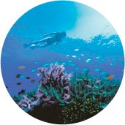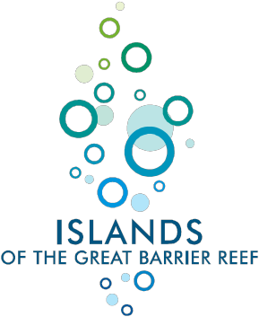

**The Best Job in the World – Island Caretaker Great Barrier Reef**

**About the job**

Tourism Queensland is seeking applicants for the best job in the world! The role of Island Caretaker is a six-month contract, based on luxurious Hamilton Island in the Great Barrier Reef. It’s a live-in position with flexible working hours and key responsibilities include exploring the islands of the Great Barrier Reef to discover what the area has to offer. You’ll be required to report back on your adventures to Tourism Queensland

headquarters in Brisbane (and the rest of the world) via weekly blogs, photo diary, video updates and ongoing media interviews. On offer is a unique opportunity to help promote the wondrous Islands of the Great Barrier Reef.

Other duties may include (but are not limited to)

Feed the fish - There are over 1,500 species of fish living in the Great Barrier Reef. Don’t worry – you won’t need to feed them all.

Clean the pool - The pool has an automatic filter, but if you happen to see a stray leaf floating on the surface it’s a great excuse to dive in and enjoy a few laps.

Collect the mail – During your explorations, why not join the aerial postal service for a day? It’s a great opportunity to get a bird’s eye view of the reef and islands.

**About the job package**

Living above the Great Barrier Reef is a pretty unique benefit, but the successful candidate will also be paid a salary package of AUD $150,000 for the six-month contract. You’ll receive return airfares from your nearest capital city (in your home country), accommodation and transport on Hamilton Island, travel insurance for the contract period, computer, internet, digital video and stills cameras access, plus travel to a number of the

other Islands of the Great Barrier Reef. The six-month contract commences 1st July

2009.

**About the location**

Stretching for 2,600 kilometres, and composed of over 2,900 individual reefs and 900 islands, the Great Barrier Reef in Queensland, Australia is the world’s largest coral reef system. The World Heritage Listed area supports a diversity of wildlife including whales, dolphins, sea turtles and more than 1,500 species of fish. The reef is an extremely popular destination for tourists, sustainably managing approximately 2 million visitors each year.

**Education/Experience Requirements:**

A broad range of experience will be considered, but the successful applicant should posses:

 Excellent interpersonal communication skills

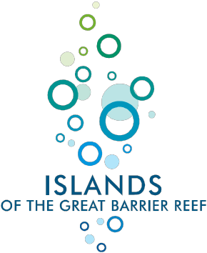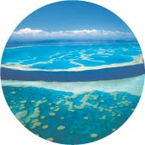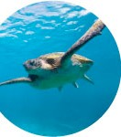

 Good written and verbal English skills

 An adventurous attitude

 Willingness to try new things

 A passion for the outdoors

 Good swimming skills and enthusiasm for snorkelling and/or diving

 Ability to engage with others

 At least one year’s relevant experience

**How to apply:**

Want the best job in the world? If you enjoy new experiences and you can spare six months to enjoy life above the Great Barrier Reef, you’re already in with a good chance. It’s easy to apply.

Step 1: Create a video application (in English and in 60 seconds or less) telling us why you’re the best person for the job and demonstrating your knowledge of the Islands of the Great Barrier Reef.

Step 2: Fill out a brief application form and upload your video to [www.islandreefjob.com.](http://www.islandreefjob.com/) Applications close 11.59pm UTC 22nd February 2009

Applications open on 2.00pm UTC 9th January and close 11.59pm UTC 22nd February

2009.

**About the application process:**

Eleven candidates will be invited to the Islands of the Great Barrier Reef for an interview from the 3rd to the 7th May 2009. So, if you want the best job in the world, you’ll need to be available to travel to Queensland for the final interview selection process. You’ll also need to be available to start work on the 1st July 2009.

Tourism Queensland will select ten candidates. Visitors to [www.islandreefjob.com](http://www.islandreefjob.com/) will have the chance to select one Wild Card candidate, who will also participate in the final interview selection process.

All applicants must be eligible for a short term business visa for the interview selection process and a long term temporary employee visa for the contract period.

**For more information and to apply please visit** [**www.islandreefjob.com.**](http://www.islandreefjob.com/)